**Gujarat Technological University** Chandkheda, Ahmedabad

Affiliated

 

**RB Institute of Management Studies**

A Report On :

**Multi Service**

**Application**

Under Subject of

Software Project-3

MCA Sem : 4

**Academic Year (2023-2024)**

# 

# **GROUP MEMBERS :**

|  |  |  |
| --- | --- | --- |
| **No** | **Name** | **Enrolment No** |
| 1 | Mori Nikunjkumar M. | 225490694056 |
| 2 | Nagar Praful K. | 225490694057 |

**Index**

|  |  |
| --- | --- |
| **Content** | **Page No** |
| 1. Introduction   1.1 Existing System  1.2 Need for the New System  1.3 Objective of the New System  1.4 Problem Definition  1.5 Core Components  1.6 Project Profile  1.7 Assumptions and Constraints  1.8 Advantages and Limitations of the Proposed System |  |
| 1. Requirement Determination & Analysis   2.1 Requirement Determination  2.2 Targeted Users |  |
| 1. System Design   3.1 Use Case Diagram  3.2 Class Diagram  3.3 Sequence Diagram  3.4 Activity Diagram  3.5 Data Dictionary |  |
| 1. Screenshots of main modules   4.1 App  4.2 Admin |  |
| 1. Agile Documentation   5.1 Agile Project Charter  5.2 Agile Roadmap / Schedule  5.3 Agile Project Plan  5.4 Agile User Story (Minimum 3 Tasks)  5.5 Agile Release Plan  5.6 Agile Sprint Backlog  5.7 Agile Test Plan  5.8 Earned-value and burn charts |  |
| 1. Proposed Enhancements |  |
| 1. Conclusion |  |
| 1. Bibliography |  |

1. **INTRODUCTION**

* In this fast-growing technology, we still have to take the appointment of person who solve the problems related to our daily life like plumbing related problem, mechanical problem, electrical problem, electronic problem, pest control etc.
* To take the appointment of service provider we have to call him or with the personal meeting we can meet him, and it is not sure that we get the appointment of the service provider at a time because there are many problems occur, like the service provider is busy at somewhere else or he is not present at his office when we go there or he wants heavy cost for fix the problem etc.
* We are not getting any service on time and also not proper changes of services. It is also not secure in terms of safety concern.
* To overcome this type of problem we are going to make our android application where the people get appropriate result.
* This android application is very dynamic and very easy to understand. The interface of the android application is very easy and anybody can easily work on it.
* The Household service android application is also very useful because the customer doesn’t have to visit to service provider’s office, he/she can easily book his/her order via this application and he/she can also pay the payment online in this android application So, he/she can book service without any kind of disturbance.

**1.1**  **Existing System**

* **Manual Booking Processes**: Service requests and appointments are managed through phone calls or in-person interactions, relying on paper-based records.
* **Limited Accessibility**: Users must physically visit service providers or rely on local directories to find available services, limiting options and convenience.
* **Dependency on Word-of-Mouth**: Recommendations from friends, family, or neighbours serve as the primary source for identifying reliable service providers, often leading to delays in finding appropriate assistance

**1.2 Need for the New System**

The followings are needs for new system:

* **Convenience and Accessibility:** An online home services app provides users with the convenience of accessing a wide range of services from the comfort of their own homes, eliminating the need for physical visits or reliance on word-of-mouth referrals.
* **Efficiency in Booking and Management:** With an online platform, users can easily schedule appointments, track service progress, and make payments in a streamlined manner, reducing time and effort spent on manual coordination.
* **Expanded Service Options and Transparency:** Online home services apps offer users access to a diverse pool of service providers, enabling them to compare options based on reviews, ratings, and pricing, thus enhancing transparency and facilitating informed decision-making.

**1.3 Objective of the New System**

We have observed how limitations in existing system:

* Existing system is offline.
* Difficult to manage records.
* No time limit for service to be provided.
* No guarantied service.
* Difficult to find paper service provider.
* 24 hours service is not available.
* No security.

So, our purpose is to overcome this limitation with following features.

* House hold services easily available.
* To provide house hold services any time.
* Easy online payment.
* Saving of time.
* Make available house hold services through application.

**1.4 Problem Definition**

In contemporary society, accessing essential home services such as plumbing, mechanical repairs, electrical troubleshooting, electronic maintenance, and pest control presents significant challenges. Traditional methods of booking appointments involve time-consuming phone calls or in-person visits, often resulting in uncertainties and inconveniences for both service providers and customers. Common issues include:

**Appointment Hassles:** Securing a service appointment can be a cumbersome process due to the unpredictability of service provider availability. Factors such as conflicting schedules or last-minute cancellations can disrupt the booking process.

**Inconvenient Processes:** The need for physical visits to service provider offices adds an additional layer of inconvenience for customers, resulting in wasted time and effort.

**Cost Uncertainties:** Customers often face uncertainties regarding service costs, with providers sometimes quoting unexpected or inflated prices for resolving issues.

**Lack of Timeliness:** Delays in service delivery can exacerbate problems, leading to inconvenience and frustration for customers awaiting resolution.

**Limited Accessibility:** Individuals with mobility issues or those residing in remote areas may face challenges accessing essential home services due to geographic constraints or lack of service provider availability.

Addressing these multifaceted challenges demands an innovative approach that reimagines the home service booking process, prioritizing efficiency, transparency, and security to enhance the overall service experience for all stakeholders involved.

To this end, the challenge lies in developing a user-friendly mobile app that simplifies the service booking process and enhances the overall user experience. By adopting a human-cantered design approach, we aim to bridge the gap between artisans and users, thereby fostering greater accessibility and utilization of professional services

**1.5 Core Components**

The Multi Services App serves as the cornerstone of our project, aimed at revolutionizing the way individuals’ access and engage with essential home services. This core component encompasses several key elements essential to its functionality and user experience:

* **User Interface (UI):** The UI design prioritizes simplicity, intuitiveness, and accessibility, ensuring that users can navigate the app with ease. A clean and user-friendly interface enhances engagement and encourages repeat usage.
* **Service Provider Database:** Central to the app is a comprehensive database of verified service providers, including plumbers, electricians, mechanics, pest control experts, and other professionals. Each provider profile contains essential information such as services offered, pricing, availability, and user ratings.
* **Booking System:** The app features a streamlined booking system that allows users to schedule appointments with service providers based on their availability and service requirements. Integration with calendar functionalities ensures efficient scheduling and avoids conflicts.
* **Real-time Communication:** Seamless communication channels enable direct interaction between users and service providers, facilitating the exchange of information, scheduling updates, and service status notifications. Instant messaging or chat features enhance transparency and responsiveness.
* **Payment Gateway**: Secure payment integration enables users to make hassle-free transactions directly within the app. Multiple payment options, including credit/debit cards, digital wallets, and online banking, ensure convenience and flexibility for users.
* **Service Tracking:** Built-in tracking functionality enables users to monitor the progress of their service requests in real-time. Updates on service status, estimated arrival times, and completion notifications provide transparency and peace of mind.
* **Feedback and Rating System:** A robust feedback and rating system allows users to provide reviews and ratings based on their experience with service providers. This two-way feedback mechanism fosters accountability, quality assurance, and continuous improvement.

By integrating these core components, the Multi Services App aims to deliver a seamless, efficient, and user-centric platform for accessing and managing essential home services. Its innovative features and functionalities promise to enhance convenience, transparency, and satisfaction for both users and service providers alike.

**1.6 Project Profile**

* Project Title : Multi Services App
* Project Type : Android Application
* Frontend Tool : Flutter,
* Backend Tool : Node js, Express js,
* Database Tool : MongoDB
* Team Members : Nagar Praful

Mori Nikunj

**1.7 Assumptions and Constraints**

In the development and implementation of the Home Services App project, certain assumptions and constraints guide our approach and influence project outcomes. These assumptions and constraints are essential considerations for project planning, resource allocation, and risk management:

**Assumptions:**

* **Market Demand:** We assume that there is a significant demand for a centralized platform that connects users with reliable and verified home service providers. Market research indicates a growing reliance on digital solutions for service booking and convenience.
* **User Adoption:** We assume that users will readily adopt the Home Services App, attracted by its user-friendly interface, convenience features, and value-added services. Positive user feedback and word-of-mouth referrals are expected to drive adoption rates.
* **Service Provider Participation:** We assume that service providers will willingly join the platform, recognizing the opportunity to expand their customer base, increase visibility, and streamline their booking processes. Effective onboarding strategies and incentives are expected to encourage participation.
* **Data Security and Privacy:** We assume that robust measures are in place to safeguard user data, ensuring compliance with data protection regulations and industry standards. Users trust the app to handle their personal information securely and responsibly.
* **Technological Infrastructure:** We assume access to reliable technological infrastructure, including servers, databases, and network connectivity, to support the app's functionality and scalability. Continuous monitoring and maintenance are vital to ensure optimal performance.

**Constraints:**

* **Resource Limitations:** Limited budget, time, and human resources impose constraints on project development and execution. Prioritization of features and efficient resource allocation are essential to meet project objectives within the specified constraints.
* **Technical Challenges:** The complexity of integrating diverse functionalities, ensuring cross-platform compatibility, and addressing technical glitches poses challenges during app development. Technical expertise and troubleshooting capabilities are crucial for overcoming these challenges.
* **Regulatory Compliance:** Compliance with legal and regulatory requirements, such as data protection laws, consumer rights regulations, and industry standards, imposes constraints on app design, data handling practices, and user interactions. Adherence to compliance guidelines is non-negotiable.
* **Market Competition**: The presence of established competitors in the home services industry presents a constraint on market penetration and user acquisition. Effective differentiation strategies and value propositions are necessary to stand out in a competitive landscape.
* **User Expectations:** User expectations for seamless functionality, responsive customer support, and service quality set high standards for the app's performance and user experience. Meeting and exceeding these expectations are critical for user retention and satisfaction.

By acknowledging these assumptions and constraints upfront, we can proactively address challenges, mitigate risks, and align project efforts with stakeholder expectations. Continuous monitoring and adaptation to changing circumstances are essential for project success.

**1.8 Advantages and Limitations**

**Advantages:**

* **Convenience:** Home services offer unparalleled convenience, allowing users to access essential maintenance and repair services without leaving their homes. This eliminates the need for physical visits to service provider locations, saving time and effort for users.
* **Accessibility:** Home services enhance accessibility by connecting users with a wide range of service providers, including plumbers, electricians, mechanics, and pest control experts, among others. This ensures that users can easily find solutions to their home-related issues, regardless of their location or schedule.
* **Time Efficiency:** With home services, users can quickly schedule appointments and receive timely assistance for their maintenance and repair needs. This reduces downtime associated with unresolved issues and enables users to resume their daily activities without delay.
* **Quality Assurance:** Many home service platforms vet and verify service providers to ensure quality and reliability. Users can benefit from access to reputable professionals with proven track records, enhancing confidence in the services received.
* **Transparency:** Home service platforms often provide transparent pricing, service descriptions, and user reviews, enabling informed decision-making for users. This transparency fosters trust and accountability within the service provider ecosystem.

**Limitations:**

* **Dependency on Technology:** Home services rely heavily on technology, including mobile apps, websites, and online communication channels. Technical glitches, server outages, or connectivity issues can disrupt service delivery and frustrate users.
* **Geographical Limitations:** While home services aim to enhance accessibility, they may face geographical limitations in remote or underserved areas. Limited service provider availability or infrastructure constraints can hinder the effectiveness of home service platforms in certain regions.
* **Service Quality Variability:** Despite efforts to vet service providers, quality discrepancies may still occur. Users may encounter instances of subpar service quality, missed appointments, or communication breakdowns, leading to dissatisfaction and distrust.
* **Security Concerns:** Home service platforms collect and store sensitive user data, including personal information and payment details. Security breaches or data leaks can jeopardize user privacy and erode trust in the platform's security measures.
* **Cost Considerations:** While home services offer convenience, users may face higher service costs compared to traditional DIY solutions or local service providers. Price transparency and value-for-money considerations are crucial for maintaining user satisfaction and loyalty.

By carefully considering these advantages and limitations, home service providers can tailor their offerings to meet user needs effectively while addressing potential challenges and concerns. Continuous improvement and innovation are essential for maximizing the benefits of home services while mitigating their limitations.

**2. REQUIREMENT DETERMINATION & ANALYSIS**

**2.1 Requirement Determination**

**Functional Requirements:**

* **User Registration and Profile Creation:** Users should be able to register and create profiles easily, providing essential information such as contact details and location.
* **Service Selection**: Users need the ability to select for specific services based on their requirements and preferences, such as plumbing, electrical, or pest control services. They should also be able to view detailed service descriptions, pricing, and availability.
* **Booking and Scheduling**: Users should be able to book appointments with service providers conveniently, selecting preferred dates and times. The app should provide confirmation notifications and reminders to users about upcoming appointments.
* **Real-time Communication:** Seamless communication channels, such as messaging or chat features, should enable direct interaction between users and service providers for queries, updates, and service status notifications.
* **Secure Payment Processing:** The app should facilitate secure online payments for services rendered, supporting various payment methods and ensuring the confidentiality of financial transactions.
* **Feedback and Rating System:** Users should have the option to provide feedback and ratings for service providers based on their experience, helping to maintain service quality and transparency.
* **Provider Registration and Profile Management:** Service providers should be able to register and create profiles detailing their expertise, services offered, pricing, and availability.
* **Appointment Management:** Providers need tools to manage their schedules, view upcoming appointments, and accept or decline booking requests based on availability.
* **Communication with Users:** Service providers should be able to communicate with users directly through the app to address inquiries, provide updates, and confirm appointment details.
* **Service Completion:** Providers should have the ability to mark services as completed and receive payments securely through the app.

**Non-functional Requirements:**

* **Performance:** The app should be responsive, with fast loading times and minimal downtime, to provide a seamless user experience.
* **Scalability:** The app should be designed to accommodate growth in user base and service provider network without compromising performance or functionality.
* **Security:** Robust security measures, including data encryption, secure authentication, and regular security audits, should safeguard user information and financial transactions.
* **Compatibility:** The app should be compatible with a wide range of devices and operating systems to ensure accessibility for users across different platforms.
* **Usability:** Intuitive user interfaces, clear navigation pathways, and consistent design elements enhance usability and user satisfaction.
* **Reliability**: The app should be reliable, with minimal system failures or errors, to in still confidence in users and service providers.
* **Privacy:** Strict privacy controls and data protection measures should be implemented to safeguard user confidentiality and comply with relevant privacy regulations.
* **Accessibility:** The app should be accessible to users with disabilities, adhering to accessibility standards and providing alternative navigation options for individuals with special needs.

**2.2 Targeted Users**

Identifying the targeted users is crucial for designing a home service app that meets their specific needs and preferences. Here are the targeted user profiles for the Multi Service App project documentation:

**Homeowners:**

* **Description:** Homeowners are individuals who own or rent residential properties and require various maintenance and repair services for their homes.
* **Needs and Preferences:** Homeowners seek convenient and reliable solutions for common household issues such as plumbing leaks, electrical problems, appliance repairs, and pest control.
* **Behaviour:** Homeowners are likely to use the app to search for service providers, book appointments, and communicate with professionals to address their home maintenance needs efficiently.

**Tenants:**

* **Description:** Tenants are individuals who rent residential properties and are responsible for reporting maintenance issues to their landlords or property managers.
* **Needs and Preferences:** Tenants require quick and effective solutions for maintenance issues that may arise in their rental properties, such as plumbing leaks, heating system malfunctions, or pest infestations.
* **Behaviour:** Tenants may use the app to find reputable service providers endorsed by their landlords or property management companies, schedule appointments, and provide feedback on service quality.

**Property Managers:**

* **Description:** Property managers are professionals responsible for overseeing the maintenance and operation of residential properties on behalf of landlords or property owners.
* **Needs and Preferences:** Property managers need efficient tools to manage maintenance requests, coordinate service appointments, and ensure timely resolution of issues to maintain tenant satisfaction and property value.
* **Behaviour:** Property managers may use the app to access a network of trusted service providers, track maintenance requests, communicate with tenants and service professionals, and monitor service quality through user feedback.

**Service Providers:**

* **Description:** Service providers are professionals or companies offering a wide range of home maintenance and repair services, such as plumbers, electricians, etc.
* **Needs and Preferences:** Service providers seek opportunities to expand their customer base, streamline appointment scheduling, and improve communication with clients to deliver high-quality services and grow their businesses.
* **Behaviour:** Service providers may use the app to create profiles showcasing their expertise, availability, and customer reviews, manage their schedules, communicate with clients, and track service requests for efficient service delivery.

By understanding the needs, preferences, and behaviours of these targeted user groups, the Multi Service App can be tailored to provide a seamless and satisfactory experience for both users and service providers.

**3. SYSTEM DESIGN**

* 1. **Use Case Diagram**

A use case diagram is used to represent the dynamic behaviour of a system. It encapsulates the system's functionality by incorporating use cases, actors, and their relationships.

* They provide the simplified and graphical representation of what the system must actually do.

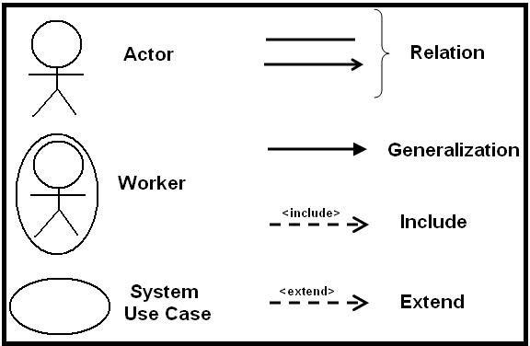

**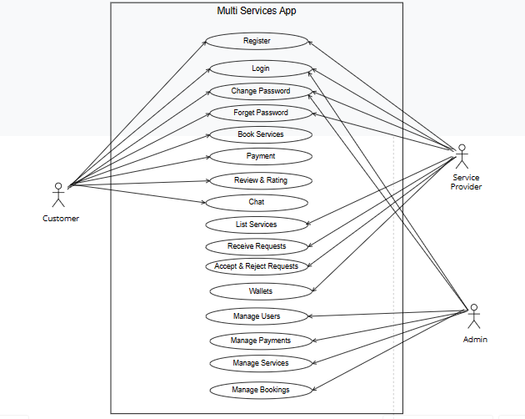**

**3.2 Class Diagram**

This is the most used UML diagram in the field of software engineering design. It is called as a main building block of any object oriented solution. Usually it illustrates the classes in a system, attributes and operations of each class and also the relationship between each class.

* Below is the “class diagram” of our new proposed system.

**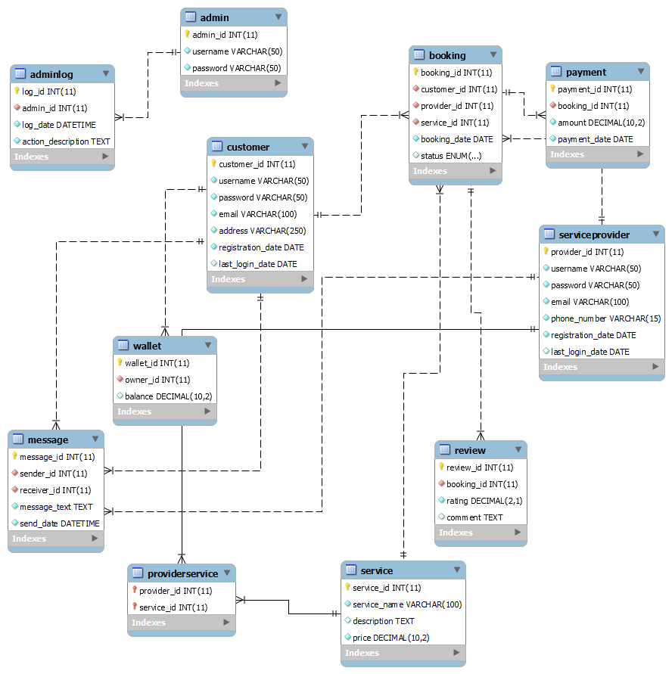**

**3.3 Sequence Diagram**

The sequence diagram represents the flow of messages in the system and is also termed as an event diagram.

**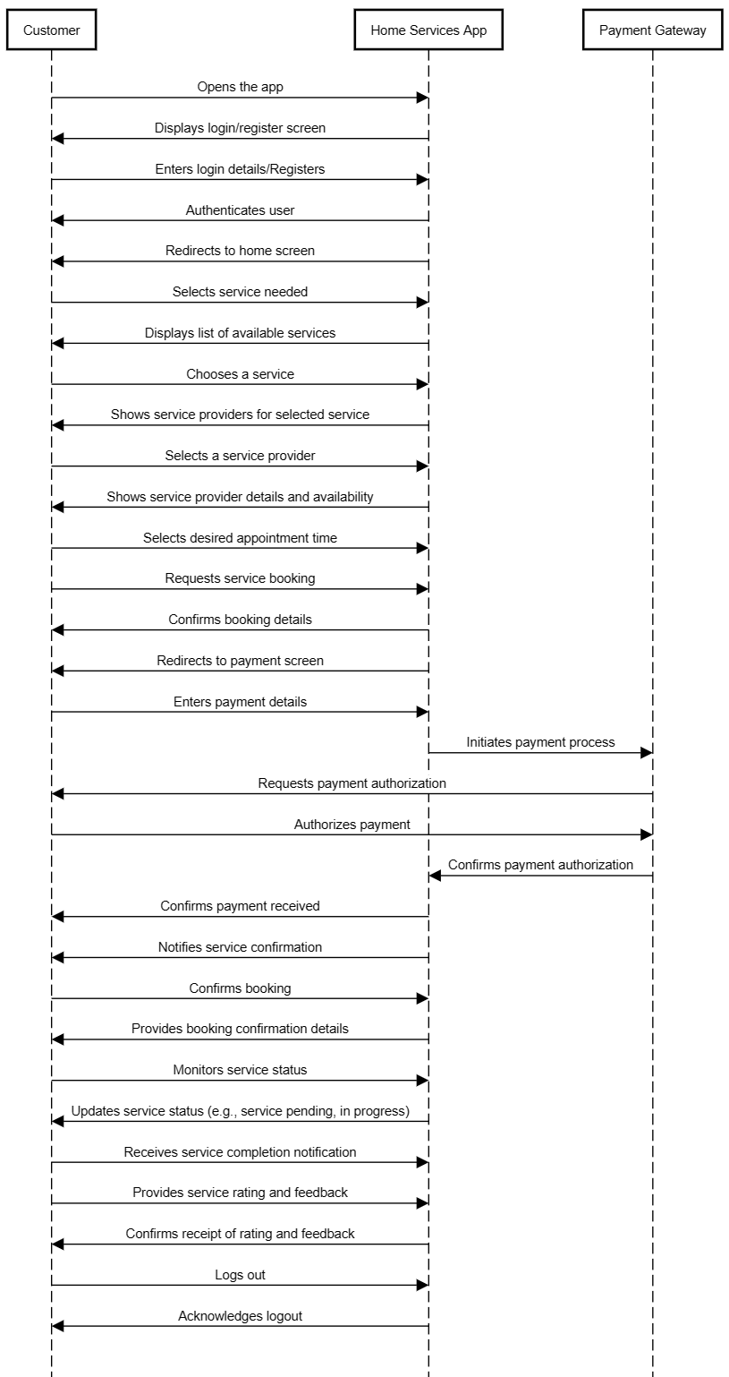**

**3.4 Activity Diagram**

In UML, the activity diagram is used to demonstrate the flow of control within the system rather than the implementation. It models the concurrent and sequential activities.

**3.5 Data Dictionary**

**User Account**

| **Column** | **Data Type** | **constraint** |
| --- | --- | --- |
| id | Int | Primary Key |
| username | Varchar(50) | Unique, Not Null |
| email | Varchar(100) | Unique, Not Null |
| password | Varchar(128) | Not Null |
| address | Varchar(128) | Not Null |
| registration\_date | Datetime | Not Null |
| last\_login | Datetime | Not Null |

**Service Provider**

| **Column** | **Data Type** | **constraint** |
| --- | --- | --- |
| id | Int | Primary Key |
| username | Varchar(50) | Unique, Not Null |
| email | Varchar(100) | Unique, Not Null |
| password | Varchar(128) | Not Null |
| phone number | Varchar(10) | Not Null |
| address | Varchar(128) | Not Null |
| registration\_date | Datetime | Not Null |
| last\_login | Datetime | Not Null |

**Admin**

| **Column** | **Data Type** | **constraint** |
| --- | --- | --- |
| id | Int | Primary Key |
| username | Varchar(50) | Unique, Not Null |
| password | Varchar(128) | Not Null |

**Admin\_log**

| **Column** | **Data Type** | **constraint** |
| --- | --- | --- |
| log\_id | Int | Primary Key |
| admin\_id | Varchar(50) | Foreign Key(Admin) |
| log\_date | Datetime | Not Null |
| action\_description | Text | Not Null |

**Booking**

| **Column** | **Data Type** | **constraint** |
| --- | --- | --- |
| id | Int | Primary Key |
| customer\_id | Int | Foreign Key(User) |
| Provider\_id | Int | Foreign Key(Service Provider) |

| **Column** | **Data Type** | **constraint** |
| --- | --- | --- |
| service\_id | Int | Foreign key(Service) |
| booking\_date | Datetime | Not Null |
| status | Pending, Accepted, Rejected | Not Null |

**Message**

| **Column** | **Data Type** | **constraint** |
| --- | --- | --- |
| id | Int | Primary Key |
| sender\_id | Int | Not Null |
| receiver\_id | Int | Not Null |
| Message\_text | Varchar(128) | Not Null |
| send\_date | Datetime | Not Null |

**Payment**

| **Column** | **Data Type** | **constraint** |
| --- | --- | --- |
| id | Int | Primary Key |
| booking\_id | Int | Foreign Key(Booking) |
| amount | Decimal | Not Null |
| payment\_date | Datetime | Not Null |

**Review**

| **Column** | **Data Type** | **constraint** |
| --- | --- | --- |
| id | Int | Primary Key |
| booking\_id | Int | Foreign key(Booking) |
| rating | Decimal | Not Null |
| comment | Text | Not Null |

**Service**

| **Column** | **Data Type** | **constraint** |
| --- | --- | --- |
| id | Int | Primary Key |
| service\_name | Varchar(100) | Not Null |
| price | Decimal | Not Null |
| description | Text | Not Null |

**Wallet**

| **Column** | **Data Type** | **constraint** |
| --- | --- | --- |
| id | Int | Primary Key |
| user\_id | Int | Foreign Key(User) |
| balance | Decimal | Not Null |
| comment | Text | Not Null |

**4. SCREENSHOTS OF MAIN MODULES**

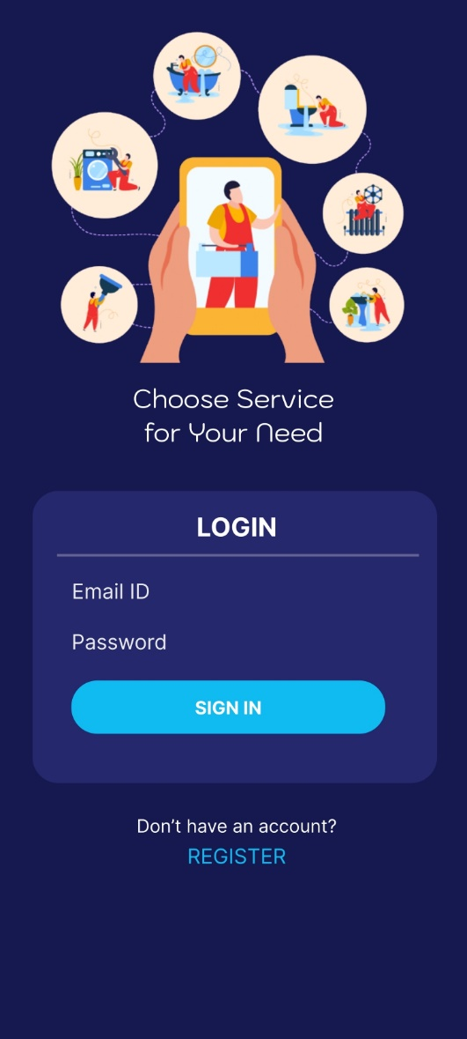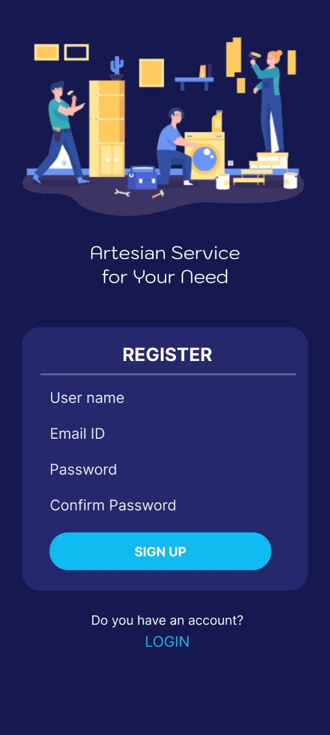

**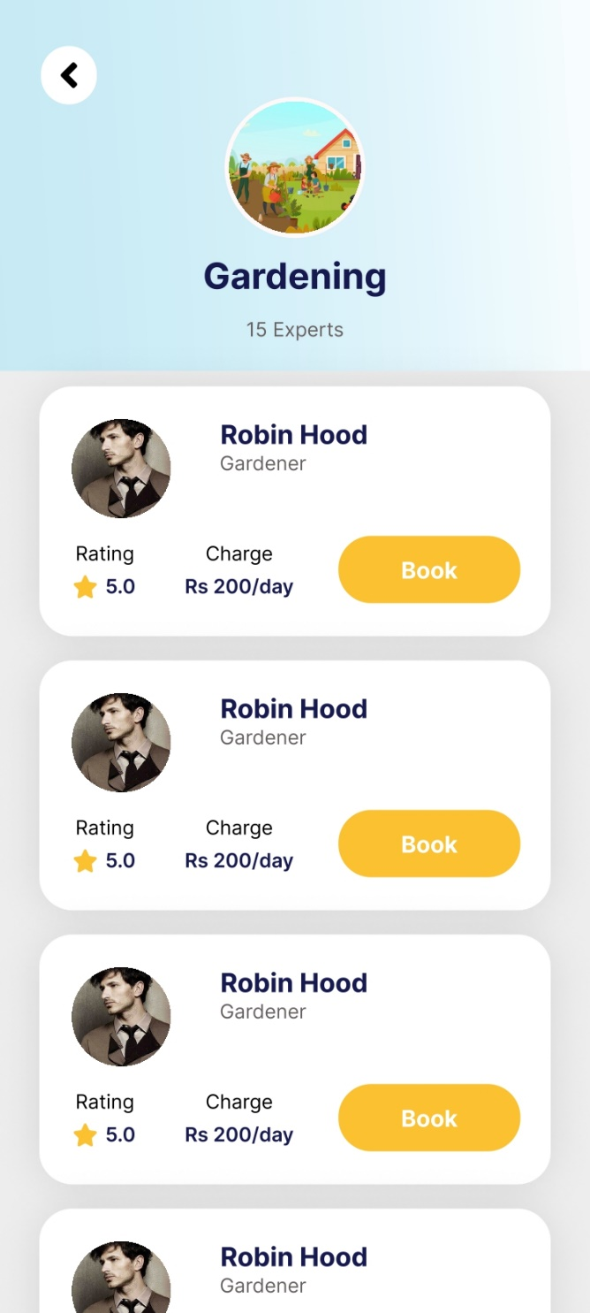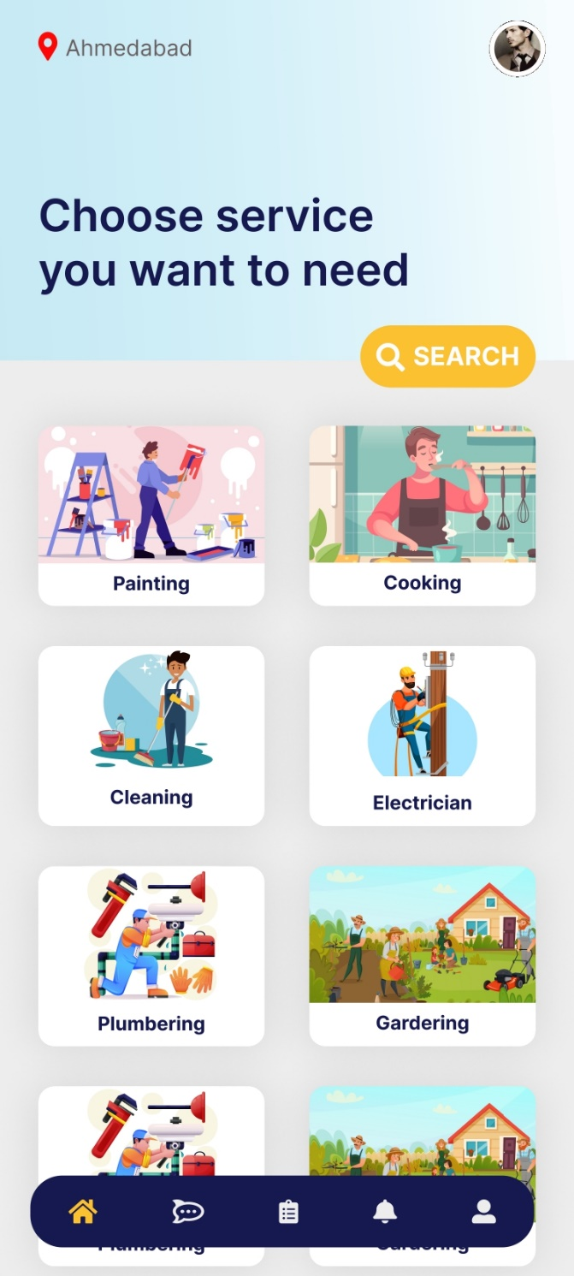**

**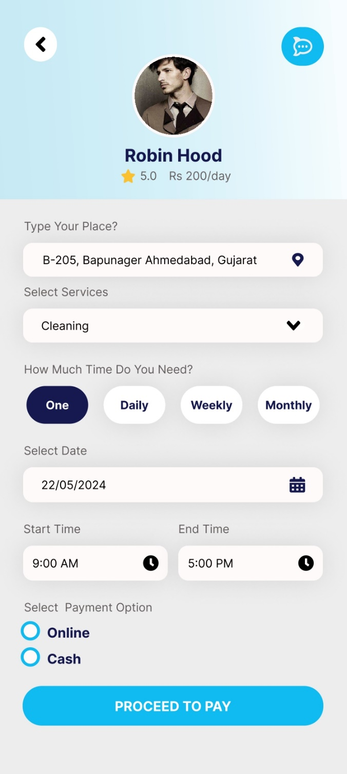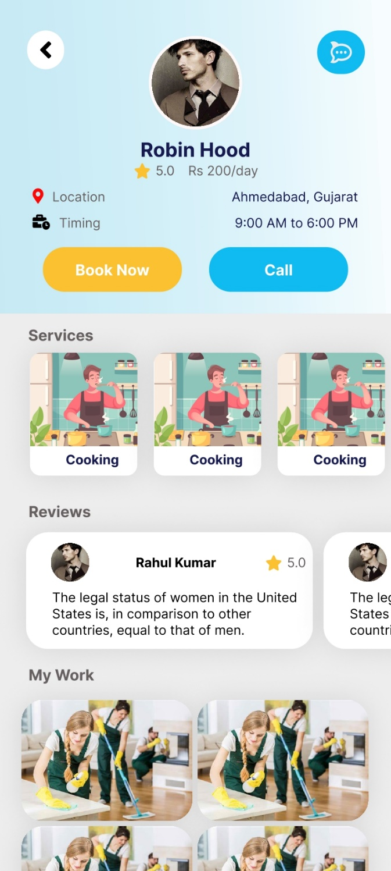**

**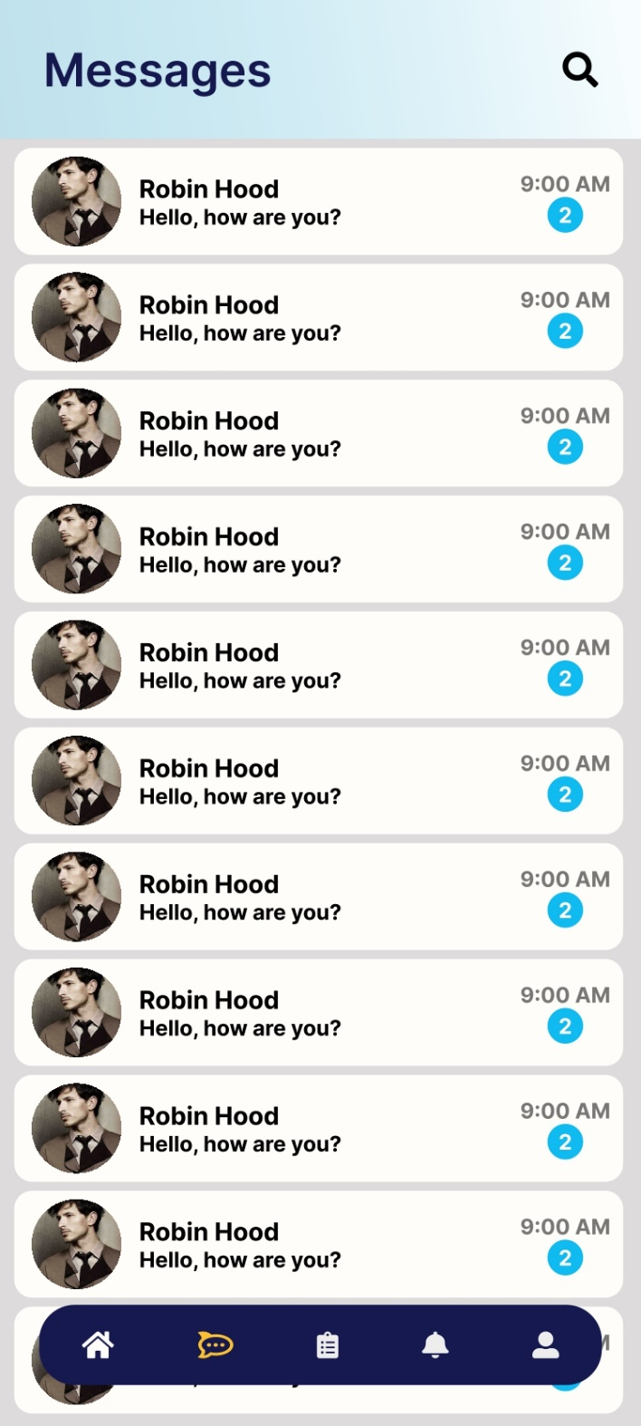**

**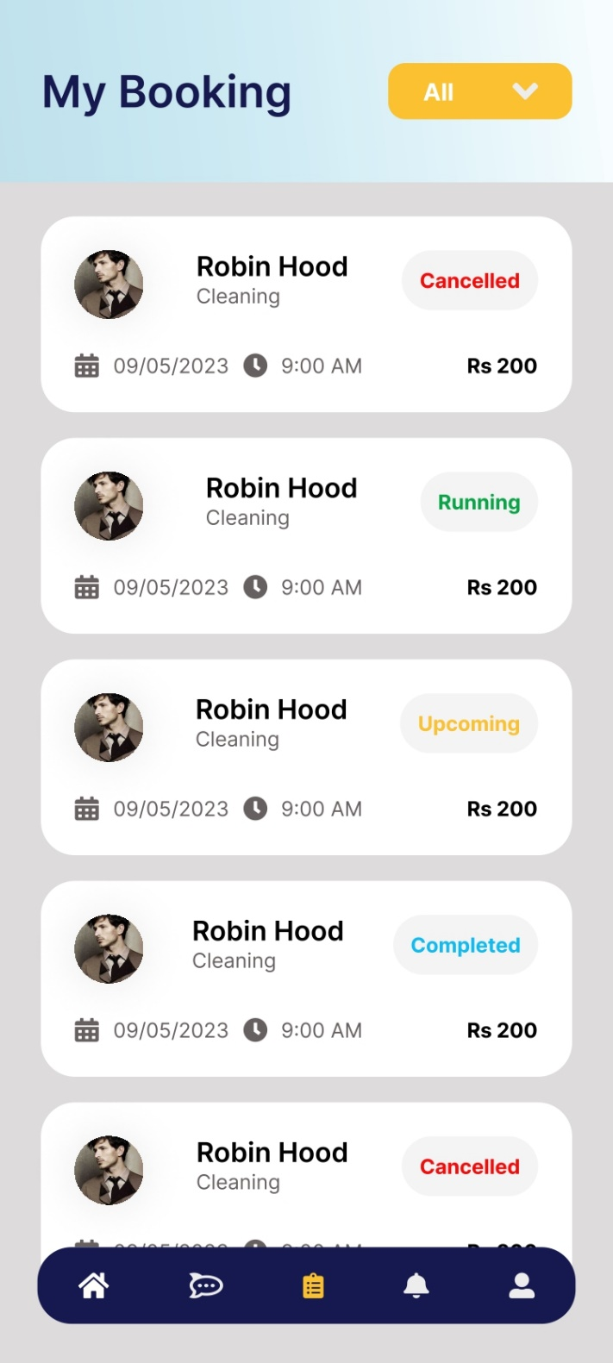**

**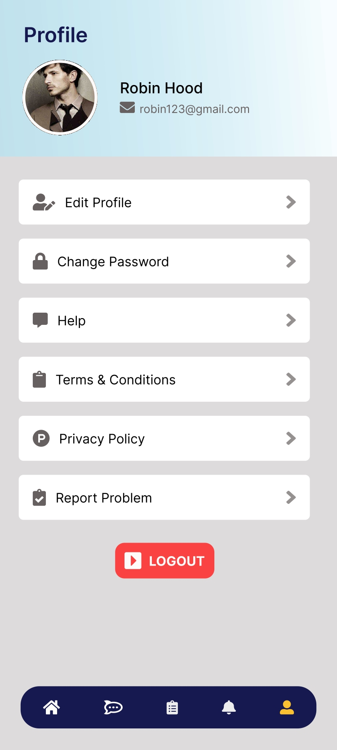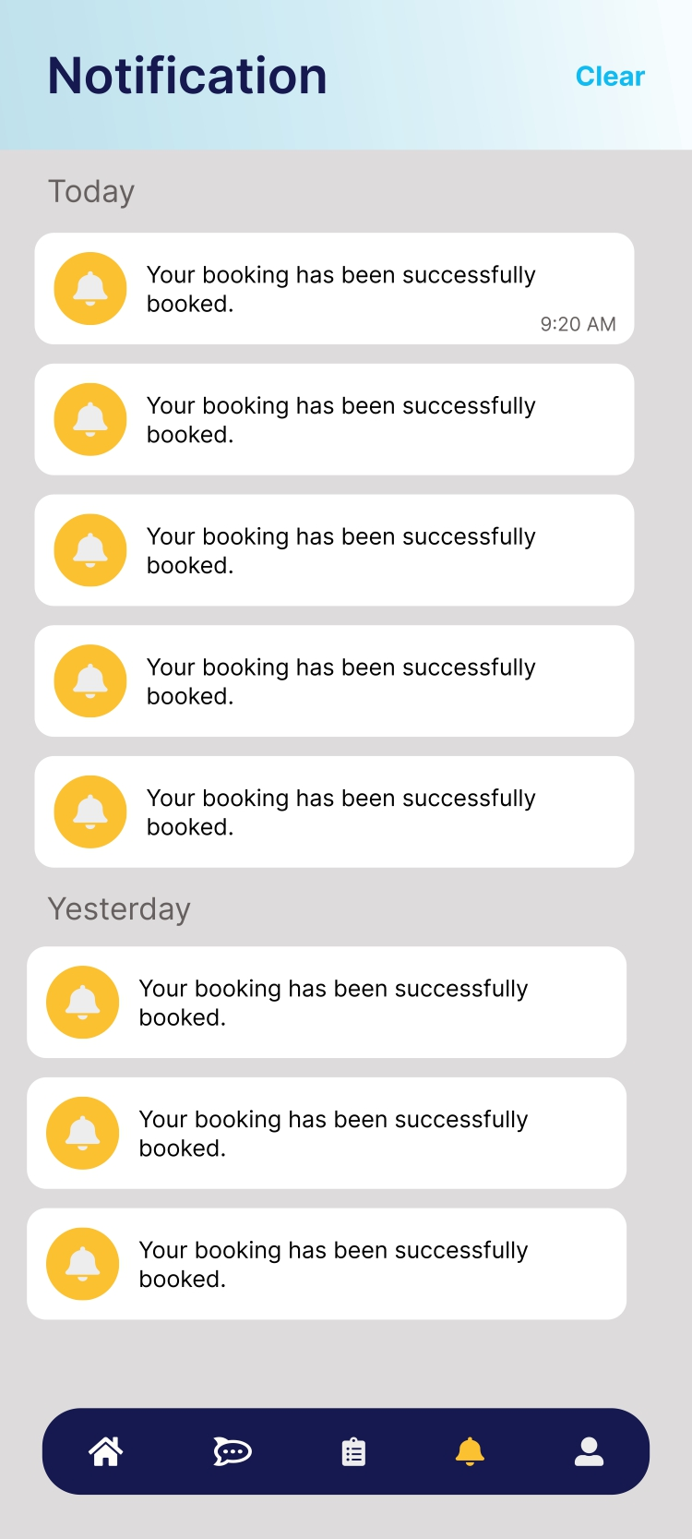**

**5. AGILE DOCUMENTATION**

|  |  |  |  |  |  |  |
| --- | --- | --- | --- | --- | --- | --- |
| Project Charter | | | | | | |
| Project Title | | | Multi Services App | | | |
| Project Start Date | 28/01/2024 | | **Project End Date** | 25/04/2024 | **Project Sponsor** |  |
| Business Need | | | | | | |
| This System is Saas (Software as a Service) based platform which provide different type of service booking for online you can book for various type of services available of our app. | | | | | | |
| Project Scope | | | | | | |
| The Service Booking Solution will consist of a mobile application for customer and service provider. The application will allow customers to search for services, view their profiles and services, and book services. | | | | | | |
| Objectives | | | | | | |
| Develop a user-friendly home services app that seamlessly connects customers with reliable service providers, facilitating efficient scheduling and payment processes. | | | | | | |
| Financials | | | | | | |
| Milestone Schedule | | | | | | |
| Milestone | | | | **Target Completion Date** | **Actual Date** | |
| Start Date | | | | 28-01-2024 | 28-01-2024 | |
| Analyze | | | |  |  | |
| Improve | | | |  |  | |
| Improve | | | |  |  | |
| Project Team | | | | | **Approval / Review Committed** | |
|  | |  | | |  | |
|  | | | | | | |

**5.1 Agile Project Charter**

**5.2 Agile Roadmap / Schedule**

|  |  |  |  |  |
| --- | --- | --- | --- | --- |
|  | **Month 1** | **Month 2** | **Month 3** | **Month 4** |
| **IMG_256** | 28-Feb-24 | 15-Apr-24 | 25-Apr-24 | 28-Apr-24 |
| **IMG_257** | Version 1 | Version 2 | Version 3 | Version 4 |
| **IMG_258** | Started our Application Designing | Started Making Modules | Started Testing | Make Documentation |
| **IMG_259** | Completed our App  Designing | Completed Making Modules | Completed Testing | Completed Documentation |
| **IMG_260** | 25% | 40% | 75% | 100% |

**5.3 Agile Project Plan**

|  |  |  |  |  |  |
| --- | --- | --- | --- | --- | --- |
| **Task Name** | **Priority** | **Owner** | **Start Date** | **End Date** | **Status** |
| **Sprint - 1 - Requirements Mapping and Design a System Flow** | | | | | |
| Gather Requirements and User Stories | High | Nikunj | 28-Jan-24 | 05-Feb-24 | Completed |
| Design User Interface | High | Nikunj | 06-Feb-24 | 15-Feb-24 | Completed |
| Define Technical Architecture | High | Nikunj | 15-Feb-24 | 28-  Feb-24 | Completed |
| **Sprint - 2 - Development & Coding** | | | | | |
| Implement User Authentication | High | Nikunj | 01-Mar-24 | 15-Mar-24 | Completed |
| Develop Booking System | High | Nikunj | 15-March-24 | 15-Apr-24 | Ongoing |

**5.4 Agile User Story**

|  |  |  |  |
| --- | --- | --- | --- |
| User Story | Role | Reason/Goal | User Story |
| As a customer, I want to be able to easily book a service through the app | Customer | Save time and hassle | As a customer, I want to be able to easily book a service through the app |
| As a customer, I want to be able to choose a service, service provider and time slot | Customer | Customize my experience and ensure I get the service I want | As a customer, I want to be able to choose a specific service, artesian, and time slot |
| I want to be able to receive reminders and notifications about my upcoming bookings | Service Provider | Be reminded of the bookings and avoid missing it | I want to be able to receive reminders and notifications about my upcoming bookings |
| As a customer, I want to be able to easily cancel or reschedule my service booking through the app | Customer | Be flexible with my schedule and avoid any cancellation fees | As a customer, I want to be able to easily cancel or reschedule my service booking through the app |

**5.5 Agile Release Plan**

|  |  |  |  |  |  |  |
| --- | --- | --- | --- | --- | --- | --- |
| Sprint | Task | Start | End | Duration | Release Date | Goal |
| 1 | User Research and Planning | 25-Jan-24 | 06-Feb-24 | 10 Days | 06-Feb-24 | Understand User Needs and Plan the Project |
| 2 | User Interface Design | 06-Feb-24 | 26-Feb-24 | 21 Days | 27-Feb-24 | Design a User-Friendly Interface |
| 3 | Backend Development and Testing | 27-Feb-24 | 25-Mar-24 | 30 Days | 25-Mar-24 | Develop a Robust Backend and Test its Functionality |
| 4 | Feature Implementation | 25-Mar-24 | 08-Apr-24 | 14 Days | 09-Apr-24 | Implement Key Features Identified During User Research |
| 5 | User Testing and Bug Fixes | 09-Apr-24 | 15-Apr -24 | 7 Days | 16-Apr -23 | Identify and Fix Any Bugs or Issues with the App |

**5.6 Agile Sprint Backlog**

|  |  |  |  |  |
| --- | --- | --- | --- | --- |
| **Task ID** | **Task** | **Estimated Effort (hours)** | **Planned Effort (hours)** | **Status** |
| 1 | User Research and Planning | 50 | 50 | Complete |
| 2 | User Interface Design | 70 | 70 | Complete |
| 3 | Backend Development and Testing | 220 | 220 | Ongoing |
| 4 | Feature Implementation | 120 | 120 | Ongoing |
| 5 | User Testing and Bug Fixes | 70 | 70 |  |
| 6 | Final Polish and Release | 60 | 60 |  |

**5.7 Agile Test Plan**

| **Test** | **Action** | **Expected Results** | **Actual Results** | **Pass?** |
| --- | --- | --- | --- | --- |
| 1 | User registration | Should be able to register | User can register | ✔ |
| 2 | User login | Should be able to log in | User can log in | ✔ |
| 3 | User book service | Should be able to book a service | Service is booked successfully |  |
| 4 | User view bookings | Should be able to view the bookings details | Booking details are displayed correctly |  |
| 5 | User cancel bookings | Should be able to cancel a booking | Booking is cancelled successfully |  |
| 6 | User receive confirmation email | Should receive confirmation email after booking | An email is sent to user |  |
| 7 | Data save in database | All data should be saved in database | Data is saved in the database | ✔ |

**6. PROPOSED ENHANCEMENTS**

* **Expansion of Service Categories:** Expand the range of services offered on the platform to include additional categories such as pet care, gardening, and personal grooming, catering to a broader spectrum of user needs and preferences.
* **Implementation of Loyalty Programs:** Introduce loyalty programs or rewards systems to incentivize repeat bookings and foster customer loyalty, encouraging users to engage with the platform regularly while rewarding them for their continued support.

**7. CONCLUSION**

* In conclusion, the home service app revolutionizes convenience by seamlessly connecting users with reliable service providers for various household needs. With its user-friendly interface, extensive service categories, and secure payment system, the app simplifies the process of finding and booking services, enhancing efficiency and satisfaction for both users and service providers alike. Embracing innovation, accessibility, and quality, this app epitomizes the future of home maintenance solutions.

**8. BIBLIOGRAPHY**

* <https://chat.openai.com>
* [YouTube](https://www.youtube.com/)
* [Stack Overflow](https://stackoverflow.com/)